The reality of homes fit for heroes:
design challenges for rehabilitation technology at home

Lesley Axelrod
Interact Lab, University of Sussex
Dept Informatics, University of Sussex
Falmer, Brighton BN1 9QH
00 44 (0)1273 872778
l.axelrod@sussex.ac.uk

Biography
Lesley Axelrod’s research is concerned with human computer interaction, ergonomic factors, affective computing, health and wellbeing. She has a background in clinical practice. Lesley joined the Interact Lab at University of Sussex in 2007 and works on the Motivating Mobility project that seeks to develop technology to motivate rehabilitation practice in the home.

Dr Geraldine Fitzpatrick
Interact Lab, University of Sussex
Dept Informatics, University of Sussex
Falmer, Brighton BN1 9QH
00 44 (0)1273 678982
g.a.fitzpatrick@sussex.ac.uk

Biography
Geraldine Fitzpatrick has been the Director of the Interact lab since June 2003. She previously worked as a user experience consultant in London and prior to that as a senior research fellow with the Distributed Systems Technology Centre and Centre for Online Health in Australia. She is a principal investigator on the Motivating Mobility project.

Professor Jane Burridge
Professor of Restorative Neuroscience
School of Health Sciences
University of Southampton

Biography
Jane Burridge’s research is at the interface between Rehabilitation, Engineering and Neuroscience. She leads the multidisciplinary Motor Learning and Control (MLC) Research Programme in the School of Health Sciences. Her research focuses on restorative neuroscience, especially motor control and spasticity and the development of rehabilitation technologies such as functional electrical stimulation (FES) and robot therapy. Her research has led to advances in understanding of normal and abnormal muscle activation patterns following stroke and in Cerebral Palsy.

Professor Sue Mawson
Centre for Health and Social Care Research
Sheffield Hallam University
Biography
Sue Mawson is Professor of Rehabilitation and Director of a newly formed NIHR Collaborative, Leaderships in Applied Health Research and Care. Her research focuses on quality of life of people with neurological problems, particularly through exploration of the effectiveness of rehabilitative interventions.

Dr Penny Probert Smith
Reader in Engineering Science
Lady Margaret Hall, Sonar Imaging and Sensor Systems
Institute of Biomedical Engineering, Oxford University

Biography
Penny Probert Smith is a Reader in Engineering Science in the University of Oxford and runs the Bioinstrumentation and measurements group in the Institute of Biomedical engineering. Her interests are in real time monitoring with particular interests in data fusion and motion analysis.

Professor Tom Rodden
Department of Computer Science
University of Nottingham
Biography

Tom Rodden is Professor of Interactive Systems at the Mixed reality Laboratory at Nottingham University and Director of Equator. His research focuses on the development of new technologies to support users within the real world and new forms of interactive technology that emerge from mixing physical and digital interaction.

Professor Ian Rickets
School of Computing
University of Dundee

Biography

Ian is Chair in Assistive Systems and Healthcare computing at the University of Dundee. He was a founder member of Applied Computing, founded the Computer Vision Research Group and combines this research with seeking improvements in health care and other areas of high social impact.

Acknowledgements

We would like to acknowledge the contribution of our partner universities: Sussex, Dundee, Nottingham, Oxford, Sheffield Hallam and Southampton and Barnsley District General Hospital NHS Trust and EPSRC for grant EP/F00382X/1

Title:

The reality of homes fit for heroes: design challenges for rehabilitation technology at home

Abstract

It is widely accepted that rigorous rehabilitation exercises after a stroke can help restore some functionality. However for many patients, this means exercises at home with minimal if any clinician support. Technologies that help motivate and promote good exercises offer significant potential but need to be designed to realistically take account of ‘real’ homes and ‘real’ lives of the people who have had a stroke. As part of the ‘Motivating Mobility’ project, we carried out a series of visits to homes of people living with stroke and photographed their homes. In contrast to many utopian smart home scenarios, the elderly of today live in homes that were built as ‘homes fit for heroes’ but which have been evolved and adapted over time and present significant challenges for the design of in-home rehabilitation technologies. These challenges include the uses and repurposing of use of rooms, attitudes to and uses of existing technologies, space available in the home, feelings about different spaces within homes and individual preferences and interests. The findings provide a set of sensitivities that will help shape and frame ongoing design work for successful deployment of rehabilitation technologies in real homes.

Key words
elderly; stroke rehabilitation; human computer interaction; homes of the future; smart homes; participatory design.

The reality of homes fit for heroes: design challenges for rehabilitation technology at home

INTRODUCTION
Tools for community and home-based rehabilitation are becoming increasingly important because more people are living longer and developing long term conditions that require significant support. Stroke in particular is the single largest cause for long-term adult disability in the developed world (Millan and Davalos, 2006). Stroke-related services accounted for over 4% of the UK NHS budget in 2000 (Mackay and Mensah, 2004). Stroke is forecast to be one of the biggest burdens to health and social care in the coming decades with the majority of sufferers aged over 65 (WHO, 2006). Stroke is characterized by loss of strength and dexterity, reduced mobility, poor balance, and muscle weakness that limit physical activity, daily activities, independence and quality of life leading to economic disadvantage, social isolation, stigma and discrimination.

To ease the burden of living with stroke and the burden of supplying services for rehabilitation, the home is increasingly becoming a focus for the delivery of care in line with Government targets and initiatives which aim to support independent living (DoH, 2006).

However, demographic changes in society such as increase in proportion of elderly (EU green paper, 2005), the breakdown of family networks and working women means less informal support is available in the home for stroke survivors. At the same time formal health and rehabilitation services are often overstretched. While there is strong evidence that rehabilitation exercises can improve functional outcomes (Pomeroy & Tallis 2002; Tuke, 2008), it is also recognized that patient motivation as well as organization and coordination of stroke care are crucially important in realizing these rehabilitation outcomes (Stroke Unit Trialist’s Collaboration 2001, Maclean, Punds et al 2002). Many patients find it very difficult to carry out rehabilitation exercises at home so home practice may not be carried out at all, not practiced enough, or may be done inaccurately with reduced benefit.

New technologies have the potential to motivate rehabilitation practice in the home setting and to monitor and provide feedback on the quantity, regularity and quality of performance. A number of systems aim to motivate stroke rehabilitation by providing an engaging or ‘fun’ factor, e.g. Theragame (Kizony Weiss et al , 2006), MIT-MANUS (Masia, Krebs et al. 2007), and ‘virtual’ rehabilitation therapies (Holden, 2005; Cameirao, Bermudez et al. 2008). However, it is not clear to what extent these systems have been designed or evaluated for their fit into real homes and real lives.

We conduct this research against the backdrop of the development of ever ‘smarter’ homes and telecare, intended to support people staying in their own homes (Audit commission, 2004). Products are more often designed to fit into utopian uncluttered ‘demonstrator’ environments rather than for retrofitting into ‘real’ inhabited homes.

Motivating Mobility
The ‘Motivating Mobility’ project aims to develop a stroke rehabilitation tool for deployment in people’s homes that will fit into their everyday lives and spaces, be easy to set up and use, and that will be motivating to use. We are using novel arrangements of sensors and interactive communication technologies so as to encourage people to participate fully in their stroke rehabilitation programmes. As an examplar we are focusing on upper arm exercise regimes. A major theme in this project is to personalise approaches and treatments to the needs of the individual at multiple levels; the most appropriate input mechanism, the most appropriate content to engage and motivate people; which arrangement of sensing and communication technologies is most acceptable and useful; how to feedback results to various stakeholders; how to best assess the effectiveness of this approach; how we might scale up this approach across the healthcare system. Our team includes those living and working with stroke such as patients, carers, their social networks and voluntary sector and clinical advisers as well as academic health professionals, computer scientists and engineers.

We expect our contribution to be in building a system that links technology to the motivations and interests of real users and ensures that they carry out exercise prescribed by their physiotherapist in such a way as to gain maximum benefit from the activity, with a measurable rehabilitation value, in order to improve their mobility, independence and well being by re-connecting individuals with their own worlds and preferences. To do all this, it is vital that we gain an understanding of the different interests of individuals and configurations of their homes.

The focus of this paper is to show how a photographic record of the homes of those living with stroke informed and inspired our some of our design decisions for rehabilitation technologies, led participants to reveal their requirements and led us to consider and create guidelines for successful deployment of rehabilitation technologies in the home.

Many homes inhabited by the elderly of today benefited from post war housing booms designed to fulfill the government promise to build ‘homes fit for heroes’. To provide a more realistic view of these homes, and to inform our understanding of how and where technologies might fit into real homes and real lives, we focused our study on the homes of people living with stroke and their relationships to their homes, supported by photographic, interview and other data.

USER STUDY: USING PHOTOS OF HOMES TO EXPLORE ‘HOMES FIT FOR HEROES’

Recruitment
Following ethics approval, a cohort of nine people living with stroke was recruited via a general invitation issued to about 60 people attending three stroke clubs in West London and Surrey. Suitability of participants for inclusion in the study was assessed by their usual voluntary sector co-ordinator or health professional contact. This allowed us to ensure that the participants reflected the diverse composition of the stroke population with a range of ages, socio-economic backgrounds, interests etc. The referring contact, who knew them well, was able to alert the researcher to any relevant potentially sensitive or difficult issues, such as recent bereavement , or dysphasia (language difficulties due to stroke damage). Our information leaflet was checked for clarity and use of ‘Plain English’ and the researcher (an experienced speech and language therapist) ensured that all participants properly understood the details of participation and gave properly informed consent. A range of options was given for permission for use of images in various forms in various types of publication. Pseudonyms are used throughout this paper to disguise identities and maintain confidentiality.

Methods
The photos that are the focus of this paper were just one method we used in this study. They were supported by evidence from other methods such as semi structured interviews, probes(Gaver, Dunne et al. 1999), emotion mapping, and stimuli (described in McCarthy et al, 2005)to draw out narratives insights and discussion into interests, beliefs and feelings. Our use of methods were diversely inspired, for example by rapid rural development, design, theatre studies and human-computer interaction (HCI). It is beyond scope of paper to discuss all our work and we are focusing on photos since they proved a very powerful medium for our participants to communicate with and within our team.

We collected in the order of 214 photographs (mean of 30 per participant) and 7 hours of interview data. We carried out a thematic analysis of the photos alongside the interview data.

It is said that a picture can tell a thousand words, and photos are particularly powerful in interdisciplinary work to help those from different disciplines to visualize issues. We were inspired by photographic studies such as the work of Pover who photographed the Harold Hill housing estate and graphically showed how people personalized their living spaces (Pover, 1992). A central method we chose to inform and inspire designers was to ask participants to show us around their homes and allow us to photograph aspects that illustrated their lives and interests. We included:
- images to show the suitability of domestic settings for placement of technologies such as where participants liked to sit, to relax or work etc;
- images to illustrate attitudes to technologies;
- images to illustrate individual preferences and motivations such as items they were fond or proud of , collections they had made etc.

In conjunction with taking photos we drew layouts of homes and asked participants to indicate their positive and negative feelings about different parts of their homes. We listened and carefully recorded the resulting narratives and used our data to draw up ‘emotion maps’ of their homes, inspired ‘biomapping’) (Nold, 2007).

The range of homes
Our participants, in keeping with the demographics of the stroke population, were mainly elderly and in some cases very elderly, ranging in age from those born in the 1920s to 1950s. These generations benefitted from a series of housing acts aimed at improving the housing stock and thereby improving the health and wellbeing of the masses, such as the ‘Homes for Heroes’ campaign after the first world war and the regeneration and expansion of domestic homes in the two decades following the Second World War. The participants in our study were often still living in homes built in these post war building booms: homes that were ‘state of the art’ when they took possession of them many years ago. These ranged from pre or mid war detatched or semi-detatched houses, to flats in post-war tower blocks.

FINDINGS: HOW HOMES FIT FOR HEROES HAVE FARED OVER TIME

The layout of homes, once considered ideal, are eroded over time. Buildings are customized by owners or tenants to suit changes in individual lifestyles, interests and needs (Brand 1994). Changes are exacerbated over time and homes may not offer readily suitable sites for the deployment of rehabilitation technologies. Our illustrations show how homes once considered ‘ideal’ are now used by their elderly owners.

Repurposing of rooms and layouts within rooms

Sid had commissioned his house in 1950 when it featured as a blueprint for the home of the future in both ‘Ideal Home’ magazine and ‘The Builder’ (see Figure 1). The ‘uncluttered lines’ featured in the original design were soon obscured by ornate choices of furniture and fittings and by eventual repurposing of the room as Sid aged and his needs changed. Unable to climb the stairs to the bedroom, toilet and bathroom, he converted his sitting room into a bedroom with a commode in situ (see figure 2).

Figure 1 and 2 here

Within rooms, layouts changed to accommodate reduced mobility and to facilitate the use of aids and adaptations. For example seating was raised to make transfer from and to standing easier. Furniture was moved to make space for walking with a zimmer frame.

Pragmatic and emotional decisions about homes

People had very strong emotional attachments and pride in their homes, often developed over many years, for example by Irene who at 82 was still living in the house she had been born in. Sometimes married partners often offered immense support, but in two cases our participants had to ‘downsize’ as a consequence of divorce, subsequent to their stroke. Sylvia entered a sheltered housing scheme and Vanessa moved to a bungalow nearer to her son. In both cases they tried to adapt to reduced space and altered relationships, without compromising too greatly on their significant belongings which they said helped them to establish positive feelings and retain their sense of identity despite the enforced change of setting.

Some areas of homes triggered negative feelings. Irene described never feeling comfortable in the largest and most empty space in the house – which was the main bedroom that had always belonged to her parents until the time of their death, many years earlier. Richard felt very negative and emotionally unable to face the many unfinished maintenance and DIY tasks in his home (see figures 3 and 4).

Figure 3 and 4 here

Existing technologies

Our participants did use technologies – for example most used TV remote controllers although several reported using only a few of the buttons and were not aware of full functional possibilities. Some technologies were seen as too complicated and frequently controls on heating, washing and such appliances were left on familiar settings or left for carers to interact with. Sylvia always used the same setting on her washing machine and asked her son to make any necessary adjustments to central heating controllers. Several had access to computers – but only Leo regularly used his desktop. Mike had a laptop but found it too frustrating to try and operate it with his non preferred hand. Tom had a 10 year old PC but kept it in a disused carpentry workshop and under wraps (see figure 5).

Fig 5 here

We explored motivations and emotional attitudes to rehabilitation technologies in the home. Several of our participants had technological adaptations installed since stroke such as electrically powered beds or chairs or community alarm systems. There was reluctance to use these in some cases. There was an element of subversion in some who saw these as devices that were meant to control them in some way and so threatened their independence. People were not impressed by affordances of technology and commonly asked “Why technology”? “Why make it so complicated?”

Practical barriers to uptake of technologies

Financial, cognitive and communication challenges were illustrated in our photos.

Reduced financial circumstances meant technology costs were sometimes a barrier to uptake of technologies. Other participants were socially isolated and out of touch with the cost of living. Maintenance of the home and of technologies in it were worrying to some, or ignored by others e.g. homes with potentially dangerous electrical and damp problems or issues with cleanliness. Some participants had problems such as aphasia (difficulty with language), visual problems or mild cognitive difficulties (common in older age) or had simply lost touch with new developments making interaction with appliances and following instructions more complicated and leading to misunderstandings about technologies. Irene worried that she did not know what the ‘web’ was and she had misplaced concerns about the proposed changeover to digital TV.

Memorabilia, clutter and use of surfaces
Homes were mostly very cluttered. People showed us memorabilia, often centrally displayed with excess spilling into recesses and cupboards. Tom fondly remembered items stored in wardrobes, cleared away from view by his daughter to reduce dusting. Each person had at least one and often several significant collections of glassware, music, ornaments, charity badges, paintings, photos or travel related items which delighted their owners and triggered memories and narratives about their past lives and current interests. This furniture of the mind was inextricably linked to their lifelong memories and life stories. Irene had a small china pot purchased at Buckingham Palace on the day of her receiving an MBE. However these collections often left little room to manoeuvre and few working surfaces that technologies could employ. Richard’s kitchen had become so cluttered that he preferred to store and prepare food in his dining area.

Pastimes and social interaction

Preferred pastimes were often traditional in nature. Games and hobbies enjoyed for many years had a historical pull. Often the things they were proudest of had taken much time to create, had great aesthetic value and were prominently displayed (see figure 6). After stroke some preferred to try and regain skills such as crochet, despite their physical limitations. Others no longer found pleasure in activities which had become too difficult and preferred to try new outlets such as drawing with left (non preferred) hand. Tangible activities were perceived to offer opportunities for social interaction and were usually preferred to technological versions. For example card games on the computer were seen as unnecessarily complex compared to just playing cards in the traditional manner, with real people. Social interaction with family and friends was a priority, despite physical and geographic difficulties, but there was little realisation of how technology might empower this.
Fig 7 here

Favourite places

People did not always use space in expected ways. Each had favourite spots to sit where they thought they might practice their exercises but seating, table heights, or both, were not ergonomic so that finding suitable places for potential rehabilitation technologies is challenging. Areas with most space or most comfortable seating or a large TV system was often saved for ‘best’. The habitual everyday places to sit tended to show signs of their multiple uses and offered little footprint for a technological device (see figure 7). TV screens (which could be incorporated into our technological design) were sometimes hard to view due to small size or being obscured by other furnishings. Two participants had special trolleys supplied by their occupational therapists supplied to help them carry items around the home or to enable them to access items at a particular ergonomic height. These were used only for a few tasks and mostly kept tucked away out of sight due to their lack of aesthetic appeal.

Fig 7 here

DISCUSSION

Fitting Technologies to Homes fit for Heroes

Our findings show that far from fitting to a utopian future, the homes that were ‘ideal’ many years ago did not fit well to the changing needs of their inhabitants and in particular offered challenges for the deployment of ‘home-based’ technologies for example the uses and repurposing of use of rooms, attitudes to and uses of existing technologies, space available in the home, feelings about different spaces within homes and individual preferences and interests. This has led us to wonder about current visions of ‘homes of the future’ and how they might not stand the test of time. The reality of the future involves greater numbers of elderly people reaching a greater age and living with increased disabilities in homes filled with a lifetime of possessions reflecting the varied interests of disparate individuals. The future elderly, living throughout most of their lives in a ‘consumer’ society may have even greater numbers of possessions. At the same time economic conditions and the breakdown of family support may lead to even greater problems of home maintenance – and technology adoption and maintenance (Fitzpatrick and Stringer 2007). Two of our younger male participants, both living with family carers, were living in purpose built accommodation that was well maintained and organized. The remaining seven were all in accommodation that seemed almost swamped by accumulated furniture and belongings.

Changing technologies
The current elderly have embraced many, many changes in their lives including the introduction of many electrical devices in the homes. But they often avoid or struggle with computer technology. Often technological items, such as computers, remote controls and central heating controls are left wrapped up or untouched and simply not used (see also Stringer at al 2006). More intuitive pervasive and ubiquitous technologies may offer solutions and it is often suggested that in the future, our elderly will be ‘digital natives’ who have grown up using technologies and so are familiar and comfortable with using technologies. However an exponential rate of technology change means future generations may be more disadvantaged than the present elderly cohort.

Few of our participants had embraced technologies and for some technologies are linked to a fear of the unknown or perceived as not of their world. We may need to design products so that they are not recognizable as technologies at all, or design training for gradual familiarization.

Placement of technologies – ergonomics of space, seats and surfaces

We know that homes change over time and that space affects deployment of ubiquitous technologies in the home (Rodden and Benford, 2003). Technologies for rehabilitation will need enough space for physical movement as well as motivational appeal to get people to use them.

Our participants each had favourite places to sit or work which might lend to the placement of rehabilitation technology. Seating in these spaces was not ergonomically suitable for rehab exercises. Spaces were at worst piled with other items and activities and at best had multipurpose uses (such as used for daily meals) so they could not be dedicated to technology. This raises concerns about the advisability of presuming availability of table top space for rehabilitation technologies. It is essential for our purpose that we encourage correct movement in certain planes with the trunk, shoulder and arm joints at the correct angles. This might not be easily achieved using existing furnishings. It is an especially important consideration when we are hoping that our participants might use the technology provided for prolonged periods as non-ergonomic set up might actually cause problems associated with abnormal posture and movement such as back problems.

People simply do not have space for technology products with a large footprint in most homes. Foldaway technologies might offer one solution but it is not easy for people living with stroke to manage assembly and disassembly or find the strength and energy to get out and put away items and storage space is also at a premium. Designing technologies so they become desirable objects for display in the home might reduce the need or desire to put the technology away.

Embedding technologies seamlessly in existing space could provide another solution - so as to make use of existing daily routines and movements as part of the monitored regime But in this case we must carefully consider the ergonomics of deployment. Another solution might be to supply purpose built furniture in which we embed our technology.

Robustness and usability

It is obvious from our photos that maintenance is a problem in many homes so robust systems that require little or no maintenance are required. They must be easy to learn and use. If rehabilitation technologies are to be used and successful they must fit into real homes and settings that are extremely diverse and reflect the look and feel preferred by different individuals. Traditional desk top set ups will not be easily embraced by those who already reject or struggle with existing TV and other products and tangible innovative solutions may be required.

Personalization

Perhaps the most striking things about our photos are how personalized each home is. Motivations were tied to rehabilitation goals but also to personalized interests and feelings. Motivation after stroke is complicated by the enforced life changes due to stroke. As individual interests, motivations, and real life goals vary, so must technologies that are to engage different individuals. We are developing methods to design a personalized approach to motivational technology development by developing a framework for a ‘plug and play’ set of technologies. This will enable physiotherapists to prescribe according to needs and enable people living with stroke to choose suitable input mechanisms, activities and feedback, depending on their needs and wants and fit to their chosen homes and lifestyles.

Aesthetics

Another striking aspect was how most people strive for a certain look and feel to their homes. It is important that the technologies we develop fit to the overall aesthetic of the home (Blythe, 2005; Bowes 2003, 2005; Palen 2006). Furnishings tended (unsurprisingly) to be quite dated. As people age they have less inclination, money or energy to refurnish or redecorate. Items of furniture had often been bought during a working lifetime and intended to last. Carefully polished and maintained over many years, this furnishing style is at odds with the typical style of most modern technology. A plastic tower may be very obtrusive and sit uncomfortably beside polished wood. New items (such as the trolleys) were sometimes considered ugly and put as much out of sight as possible. We need to consider the aesthetics of products we are designing and how technology needs to look and feel to fit into individual home environments. It may need to be packaged differently or not to look like typical recent technologies that we are familiar with.

CONCLUSION
As part of our iterative participatory design methodology we have used photography to explore the homes of people living with stroke. The illustrations have proved very useful to communicate design requirements between the multidisciplinary team and we are developing guidelines for product and interaction design based on our findings from both photographic and other evidence.

Uses of houses, rooms and items in them change over time and may not reflect the original vision of the planners and architects. There is great variability between individual households, personal motivations, lifestyles and aesthetic preferences. There is great emotional investment in homes. We need to consider carefully the practical aspects when we are deploying technologies, such as the footprint of the technology, the ergonomics, the robustness and usability etc. And it is equally important that we consider the aesthetics of our design and its fit to the individual interests and styles preferred by users. We are developing guidelines to help design planning.

The photos have forcefully illustrated the need for us to personalize design at multiple levels. People are still living in the ‘homes fit for heroes’ that were designed many years ago and as people age, they lay down rich memories and collect artifacts associated with their lives that they wish to have on display. Both needs and use of homes by their inhabitants changes over time. Rather than designing for contemporary or futuristic ‘smart-homes’, we should offer design options that fit to current realities and likely futures. If technologies are to become part of the home setting, to be displayed, to be liked and to be used regularly, they must fit to individual preferences, personal motivations, lifestyles and spaces available in the home and be aesthetically or intellectually pleasing, as well as fun to use.

References
- Audit Commission. (2004). Assistive technology: Independence and well-being 4. http://www.audit-commission.gov.uk/reports/NATIONAL-REPORT.asp?CategoryID=PRESS-CENTRE&ProdID=BB070AC2-A23A-4478-BD69-4C19BE942722&fromPRESS=NATIONAL-REPORT. Accessed on 30 March 2009. Audit Commission.
- Audit Commission. (2004). Implementing telecare. Strategic analysis and guidelines for policy makers, commissioners and providers. http://www.audit-commission.gov.uk/reports/NATIONAL-REPORT.asp?CategoryID=&ProdID=BDBE0111-764C-44a4-8A66-1CB25D6974A4 Accessed on 30 March 2009
- Brand, S. (1994) How Buildings Learn: What Happens After They're Built Viking Penguin
- Blythe, M. et al, (2005) Socially dependable design: The challenge of ageing populations for HCI. Interacting with Computers, 17: 672-689
- Bowes, A. and G. McColgan. (2003). Evaluation of Home Comforts smart home technologies initiative. Final report to South Ayrshire Council. Accessed on University of Stirling.
- Bowes, A. and G. McColgan. (2005). Smart technology at home: users and carers perspectives. http://www.dass.stir.ac.uk/curr-proj/documents/Interimreport.pdf. Accessed on 5 August 2005. University of Stirling
- Cameirao M.S.; Bermudez S; Badia I; Verschure P.F.M.J. (2008) Virtual reality based upper extremity rehabilitation following stroke: A Review. Journal of Cybertherapy and Rehabilitation Spring 2008 Vol 1; Issue 1
- Dept of Health Our health, our care, our say: a new direction for community services (2006) (accessed Oct 1 2008) www.dh.gov.uk/en/Publicationsandstatistics/Publications/PublicationsPolicyAndGuidance/DH_4127602
- EU Green Paper "Confronting demographic change: a new solidarity between the generations" COM(2005) available at http://eur-lex.europa.eu/LexUriServ/site/en/com/2005/com2005_0094en01.pdf
- Fitzpatrick, G., and Stringer, M., (2007) Exploring technology influences between home, work and school: implications for managing ubiquitous technologies in the home. In Proc HOIT 2007, Chennai, Aug 2007, Springer, pp 235-250.
- Gaver, W.W., Dunne, A., & Pacenti, E. (1999). Cultural Probes. Interactions
vi(1), 21–29.
- Holden M.K. (2005), ‘Virtual Environments for Motor Rehabilitation: Review’ CyberPsychology & Behavior., 8(3): 187-211.
- Kizony R; (Tamar) Weiss P.L; Shahar M; Rand D (2006) TheraGame: A home based virtual reality rehabilitation system International Journal on Disability and Human Development Volume 5(3), July-September 2006 265-269
- Masia, L.; Krebs, H.I.; Cappa, P.; Hogan, N (2007) Design and Characterization of Hand Module for Whole-Arm Rehabilitation Following Stroke. Transactions on Mechatronics, IEEE/ASME Volume 12, Issue 4, Aug. 2007 Page(s):399 - 407
- Mackay J, Mensah G. (2004) Atlas of heart disease and stroke, World Health Organisation Publication: 51-55
- McLean N., Pound P., Wolfe C. and Rudd A. (2002) ‘ The concept of patient motivation; a qualitative analysis of stroke professionals;’, Stroke 33 (444-448)
- Millan M, Davalos A. (2006) The need for new therapies for acute ischemic stroke, Cerebrovasc Dis 22(suppl 1):3–9
- McCarthy, J., Wright, P.C. Wallace, J., and Dearden, A. The experience of enchantment in human-computer interaction. Personal and Ubiquitous Computing. 10, 6 (2005), 369-378.
- Nold C. 2007 Biomapping http://biomapping.net/index.htm (accessed Oct 1 2008)
- Palen, Leysia and Stinne Aaløkke (2006). Of Pillboxes and Piano Benches: 'Home-Made' Methods for Managing Medication, ACM Computer Supported Cooperative Work Conference 2006, 79-88.
- Pomeroy V.M; Tallis R.C. (2002) Restoring movement and functional ability poststroke: now and the future. Physiotherapy, 88, 3-17.
- Pover M. (1992) Photos of Harold Hill Housing Estate in ‘The Name of the Room’ (eds. Rivers T; Cruickshank D; Darley G. & Pawley M.) BBC Books
- Rodden T, Benford S (2003). The evolution of buildings and implications for the design of ubiquitous domestic environments. In: Proceedings of the SIGCHI 2003 conference on human factors in computing systems, Fort Lauderdale, Florida
- Stringer, M., Fitzpatrick, G., Harris, E. (2006) Lessons for the Future: Experiences with the installation and use of today’s domestic sensors and technologies. In Proceedings 4th International Conference on Pervasive Computing (Pervasive 2006). Dublin Ireland May 2006, Springer-Verlag LNCS, pp 383-399.
- Stroke Unit Trialist’s Collaboration (2001) ‘Prganised inpatient (stroke unit) care for stroke’ Cochrane Database Syst Rev 3 (CD000197)
- Teasall R.W and Kalra L (2005) ‘What’s new in stroke rehabilaition: Back to basics’ Stroke 36. 215-217
- Tuke A (2008) Constraint-induced movement therapy: a narrative review. Physiotherapy 94 105-114 www.dh.gov.uk/en/Publicationsandstatistics/Publications/PublicationsPolicyAndGuidance/DH_4127602 (accessed 27.2.09)
- WHO Neurological Disorders: Public Health Challenges (2006) www.who.int/mental_health/neurology/neurodiso/en/print.html (accessed Oct 1 2008)

Illustrations

Figure 1 Illustration from The Builder 1950
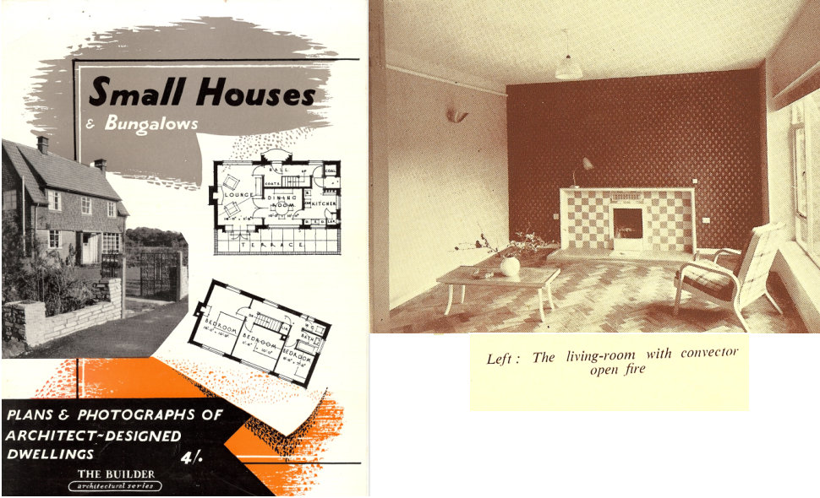

Figure 2 Same view today – used as bedroom with commode
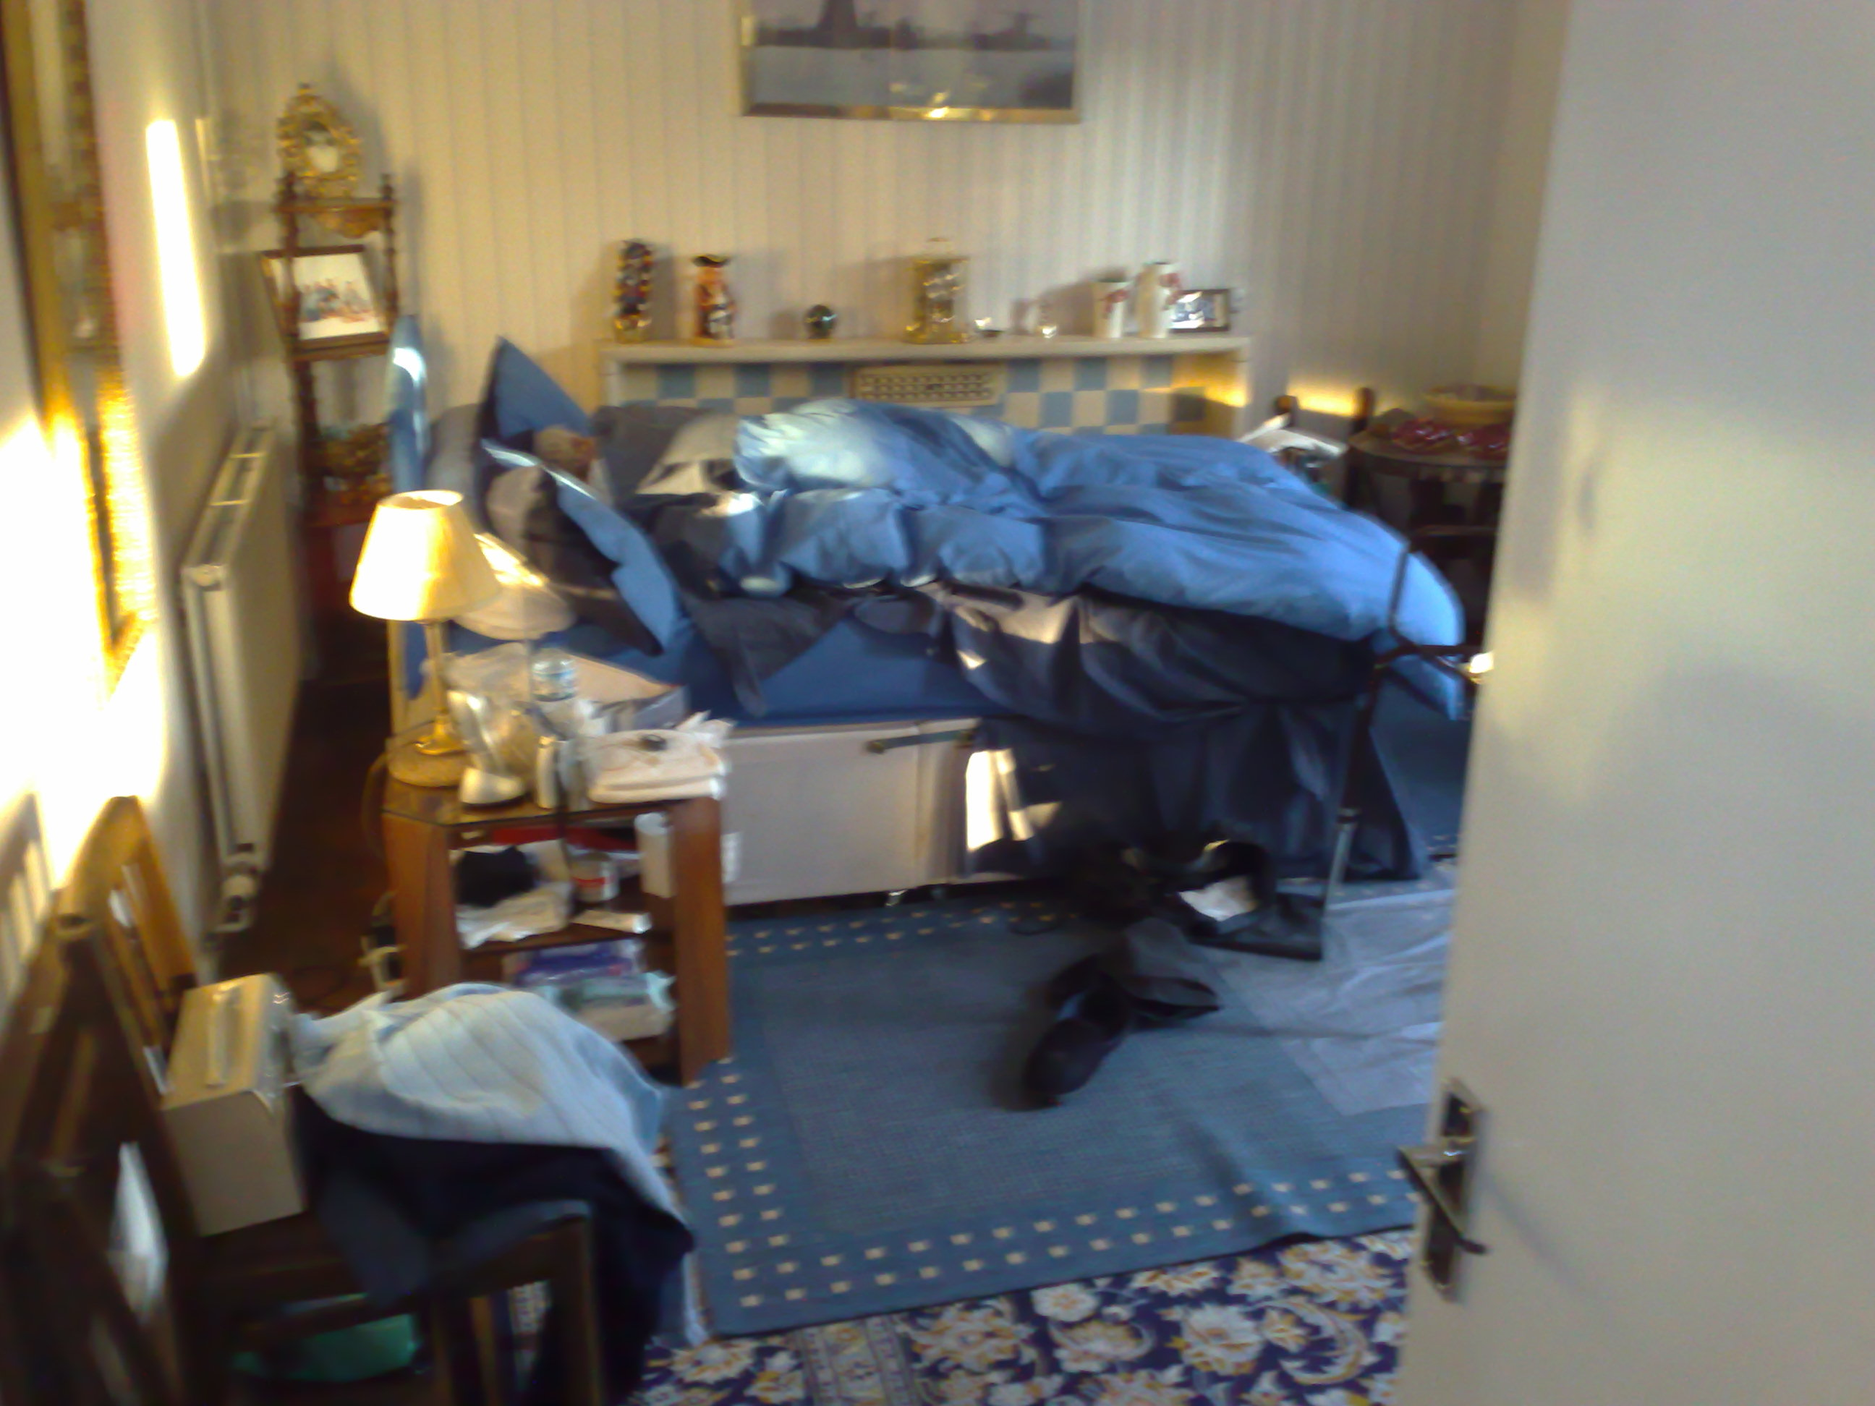

Figure 3 Emotion map of the home – red dots show anxious areas
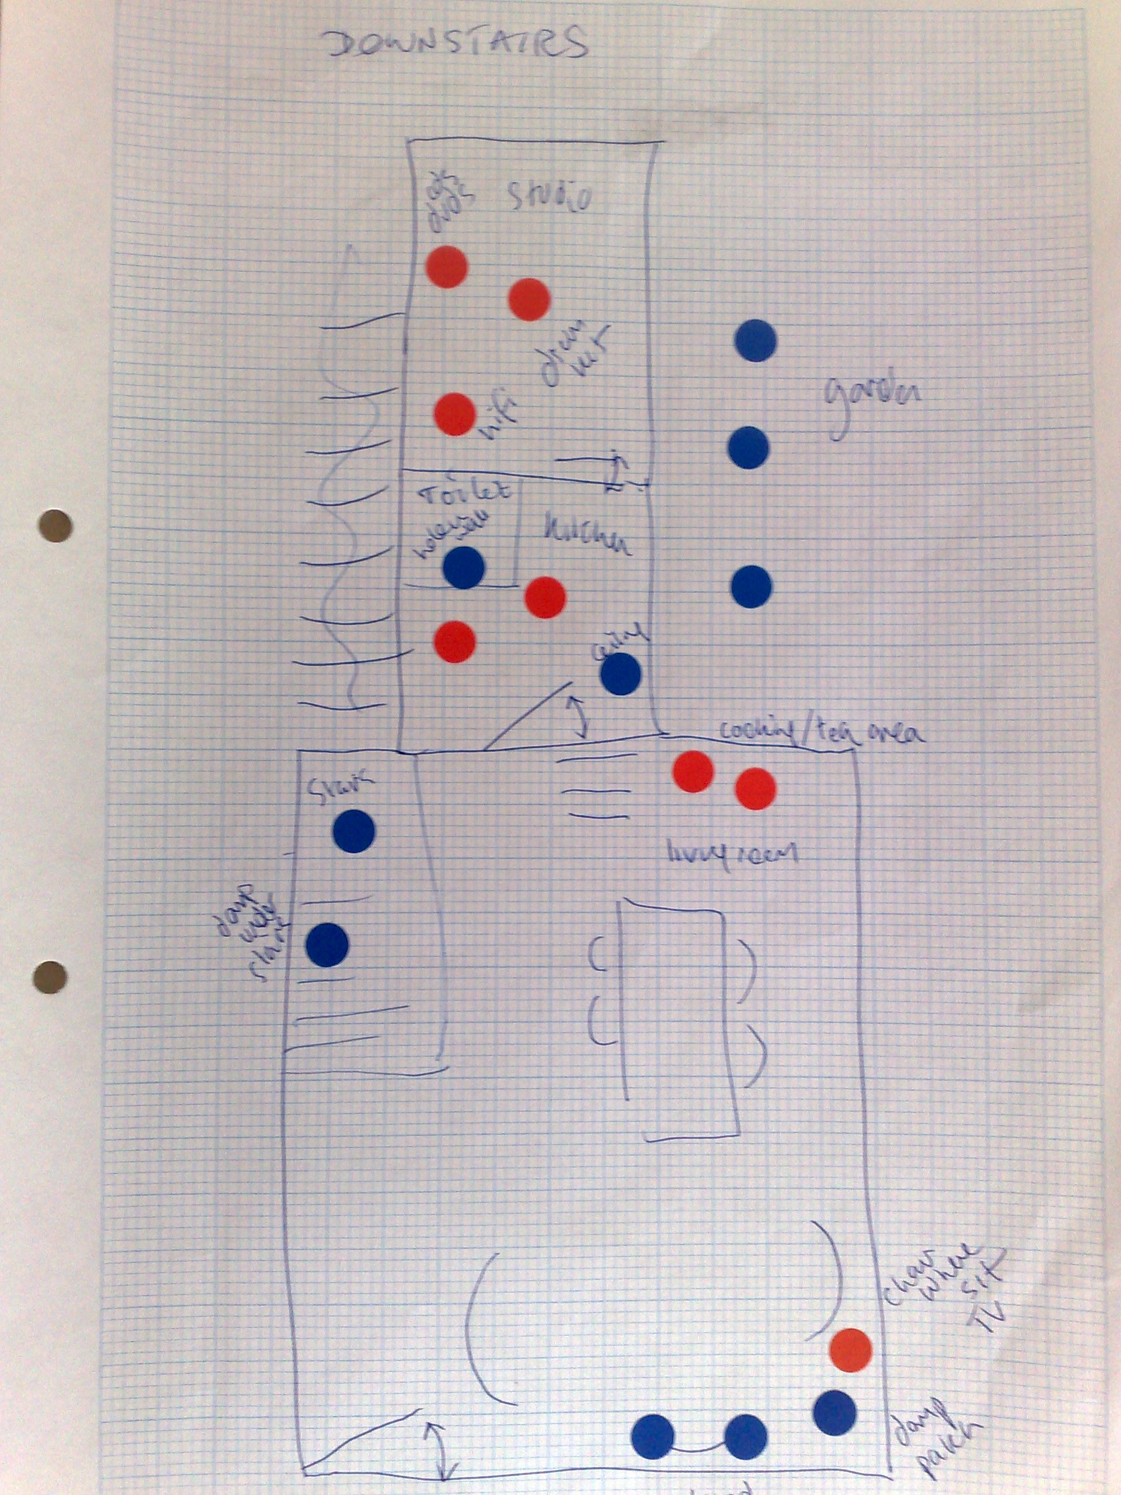

Figure 4. Maintenance problems


Figure 5. The place of existing technology
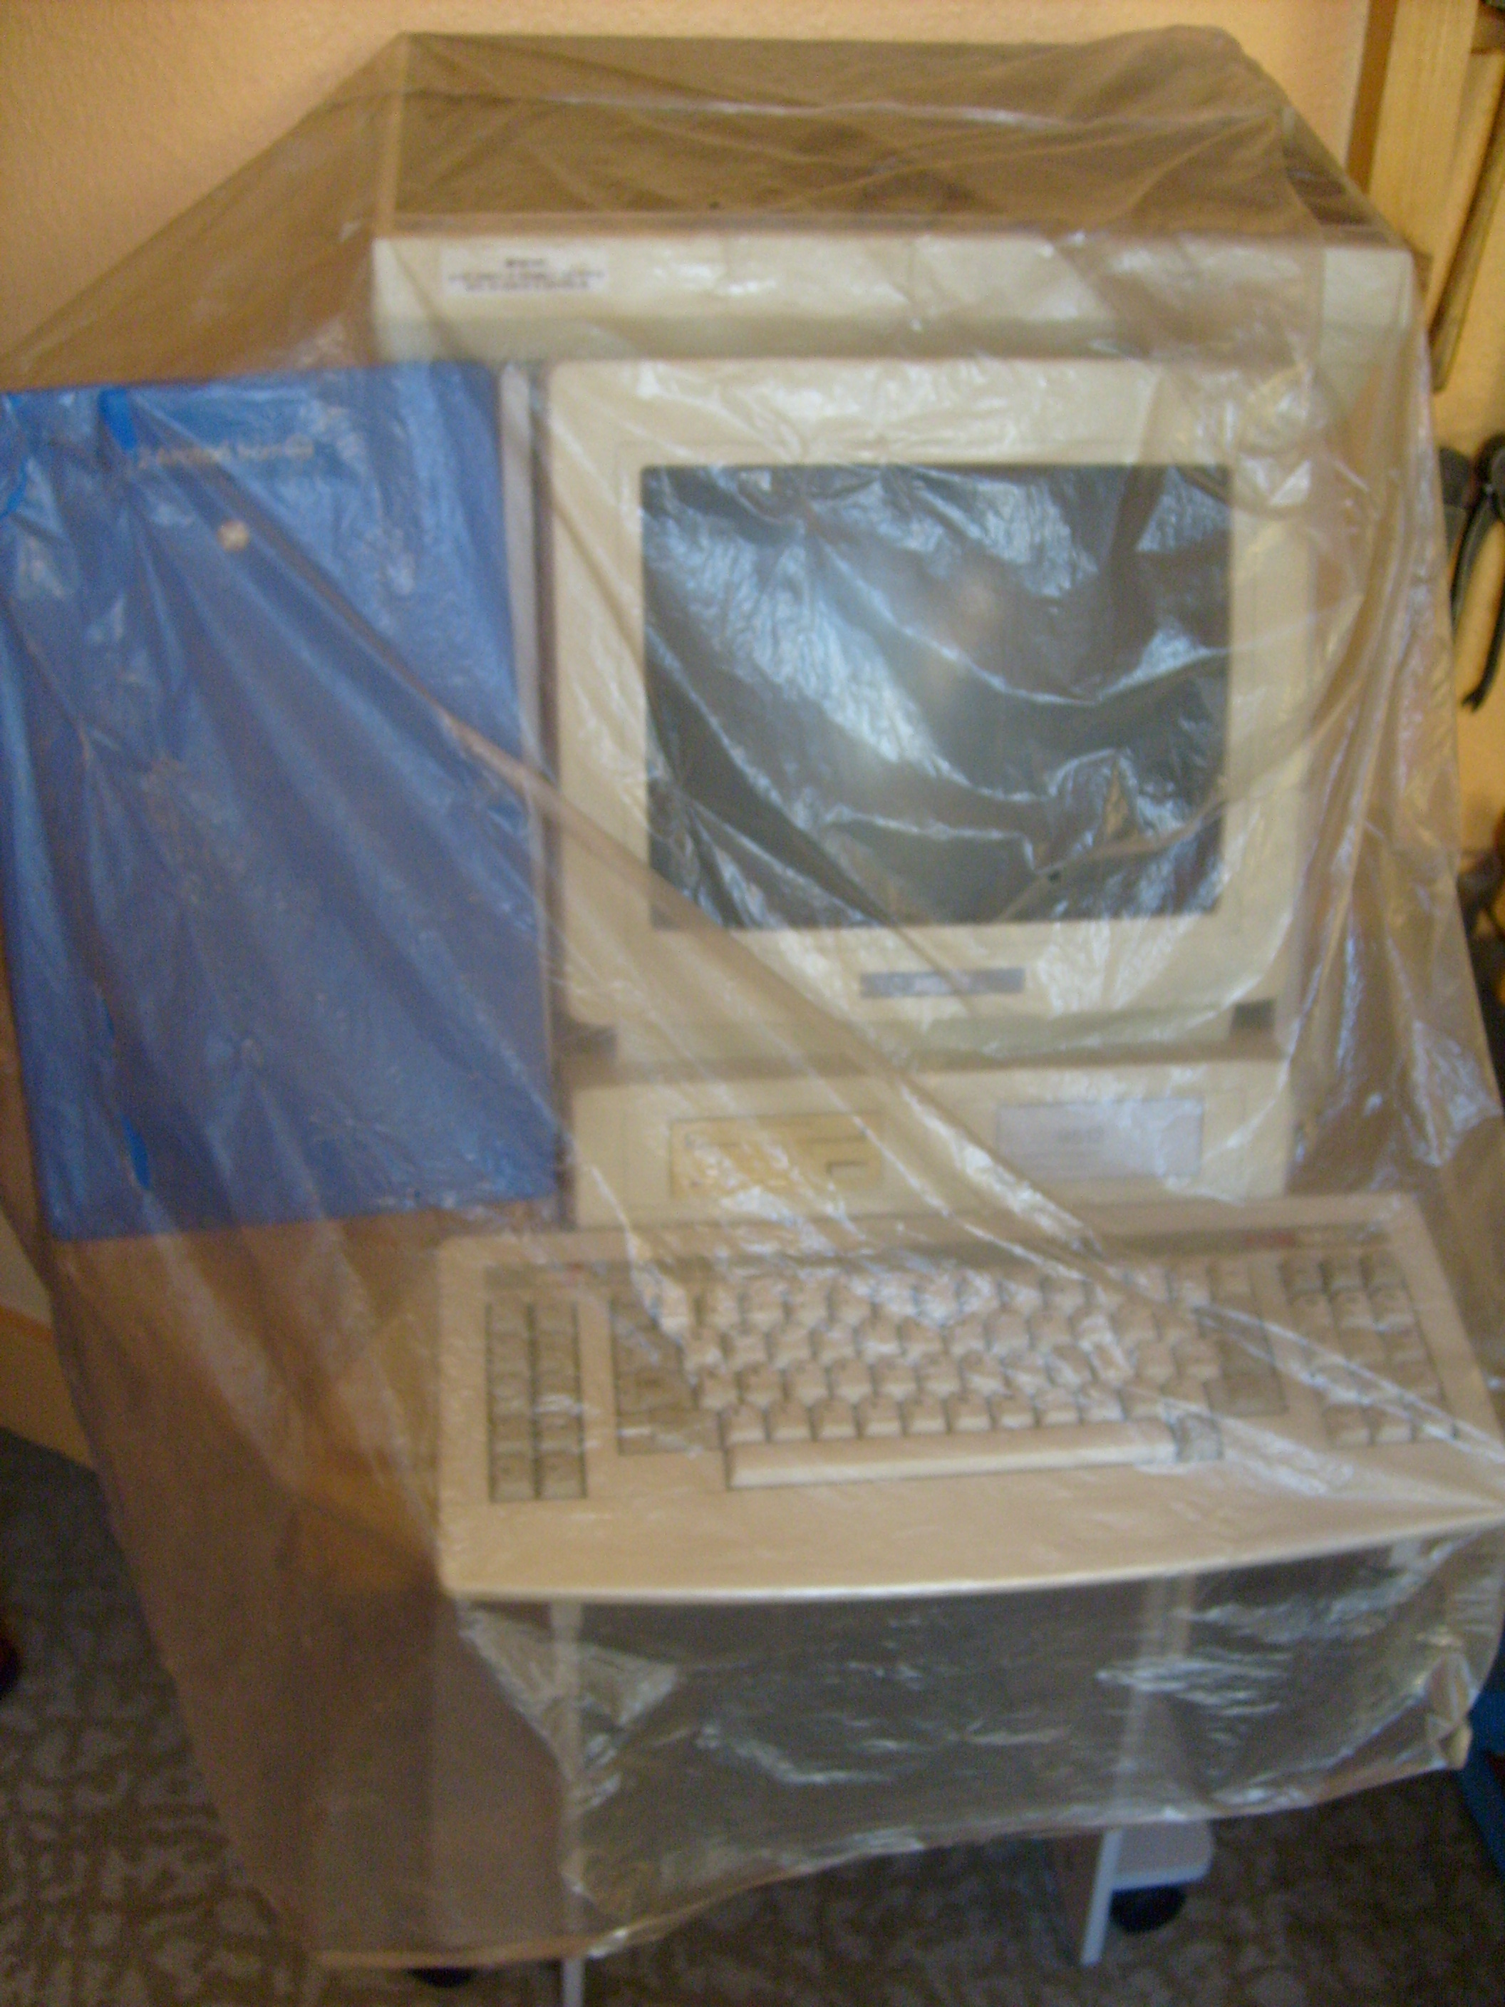

Figure 6 Glass collection
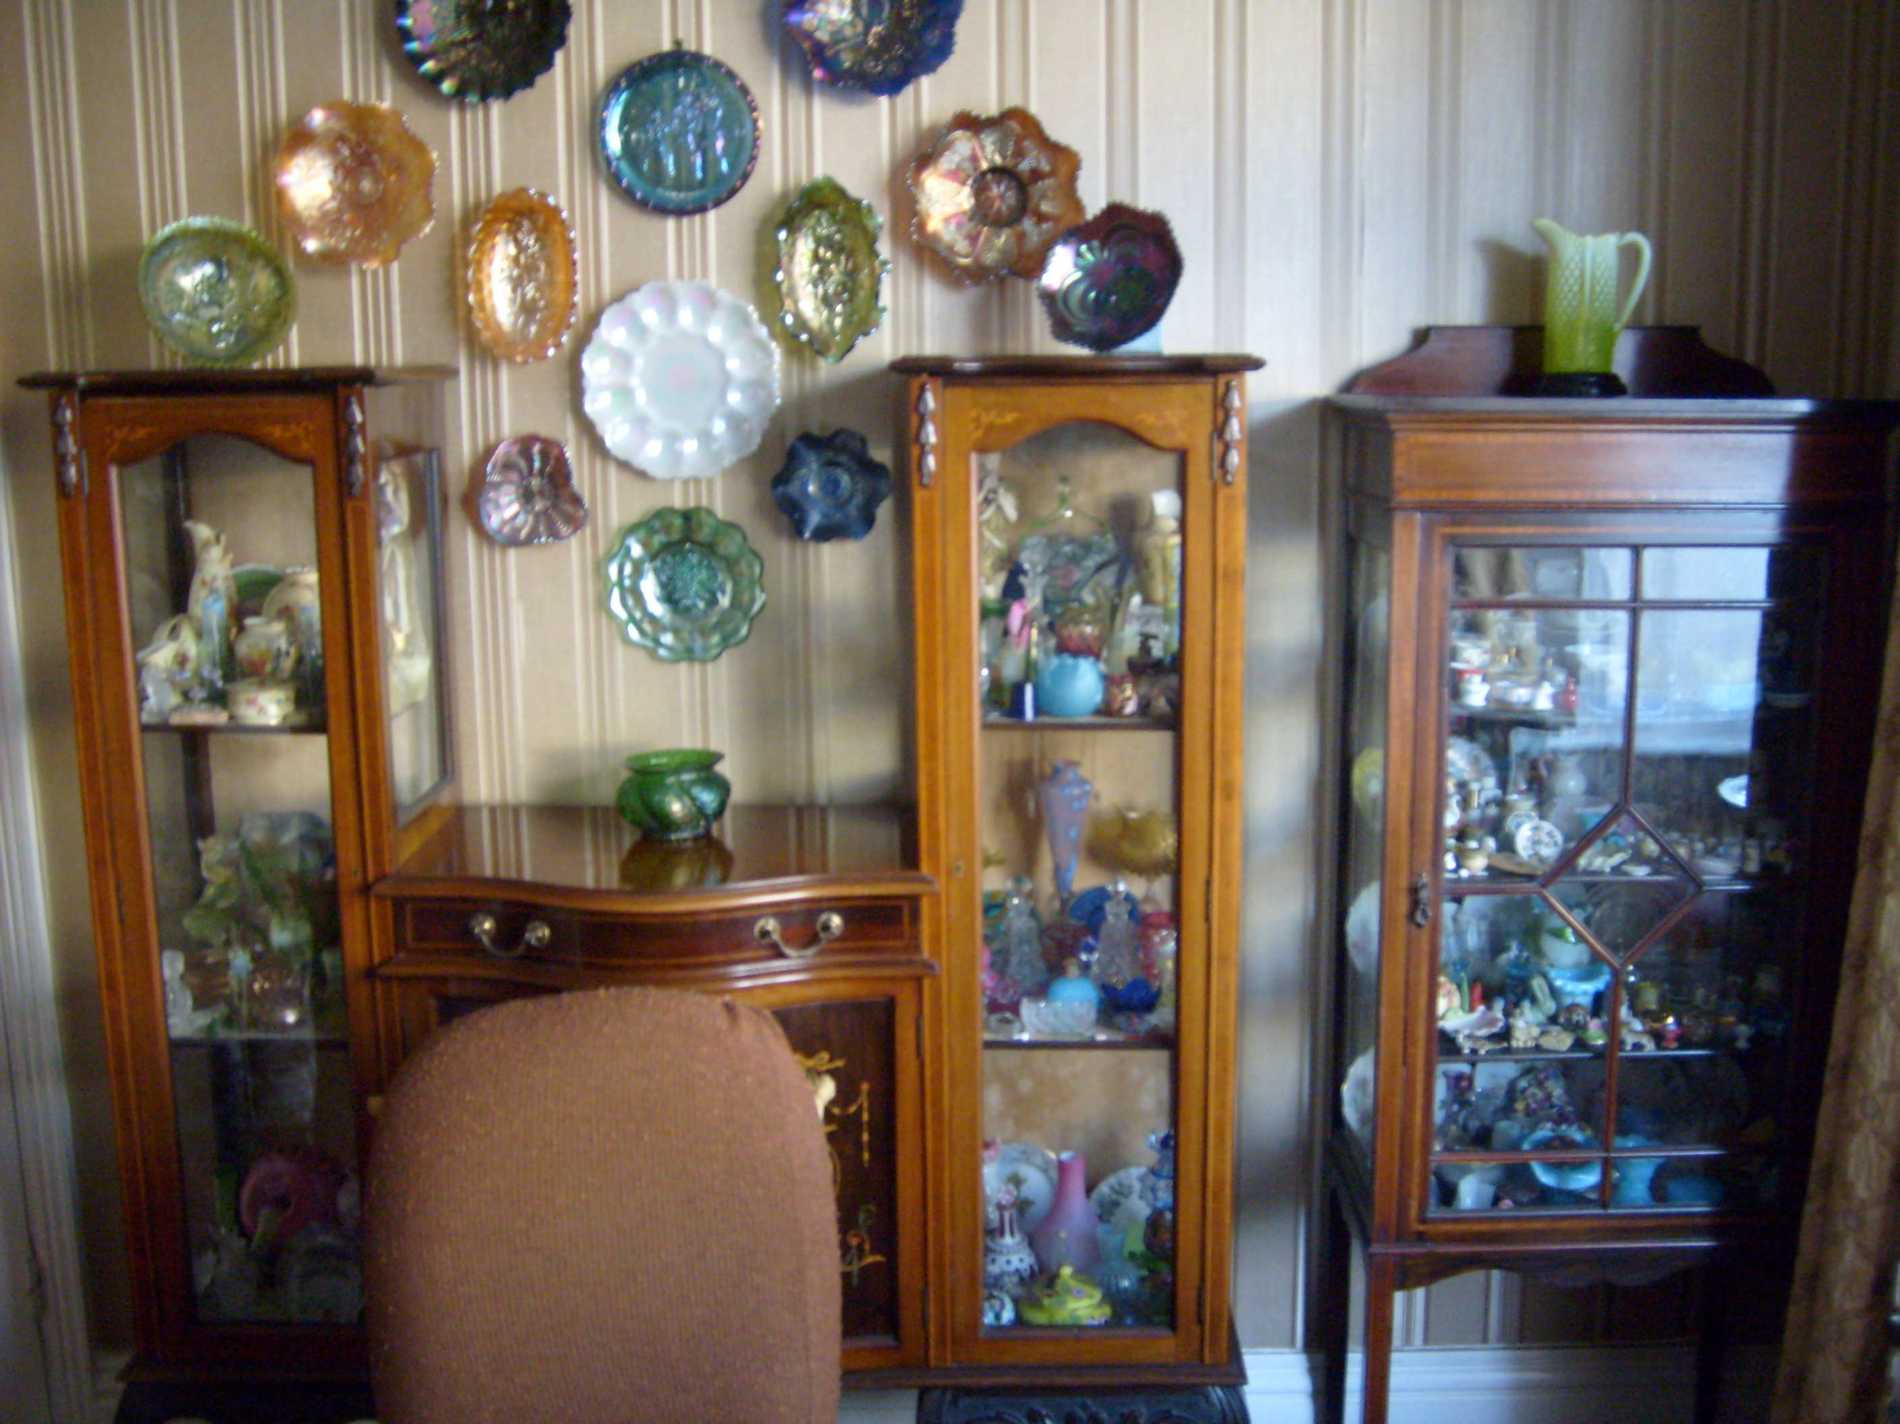

Figure 7 Multipurpose table


